**273/1**

**GEOGRAPHY**

**Paper1**

**Jul./Aug. 2019**

**2½ Hours**



**JOINT MOCK EXAMINATIONS, 2019**

**Uganda Certificate of Education**

**GEOGRAPHY**

**PAPER 1**

**2 Hours 30 minutes**

**INSTRUCTIONS TO CANDIDATES**

This paper consists of parts **I** and **II**.

Part **I** and section **A** of part **II** are compulsory.

Answer only **one** question from section **B** of part II.

Answers to **all** questions must be written in the answer booklet provide*d.*

**Turn Over**

**PART I**

**OBJECTIVE TYPE QUESTIONS**

**Answer all the 30 questions.**

1. The problem of rapid population growth in Kibaale district can be best controlled by;
2. Family planning
3. Change in land tenure system
4. Encouraging outward migration
5. Educating the masses
6. Which of the following is a sedimentary rock?
7. Chalk
8. Marble
9. Basalt
10. Granite

1. Which of the following town in East Africa is located in the rift valley area?
2. Tabora
3. Voi
4. Tororo
5. Nakuru
6. Landslides in the highland areas of East Africa are mainly caused by;
7. Earth quakes
8. Heavy rainfall
9. Cultivation on slopes
10. Use of explosives
11. Which one of the following is not a marine type of fish?
12. Tilapia
13. Salmon
14. Herrings
15. Mackerel
16. The amount of water vapour in the atmosphere is called;
17. Pressure
18. Rainfall
19. Humidity
20. Cloud cover
21. Which one of the following human activities is a minor threat to wetlands in East Africa?
22. Cultivation
23. Industrialization
24. Fish farming
25. Mining and quarrying
26. The major factor which led to the location of the Tororo cement factory in Tororo is the presence of;
27. Market
28. Labour
29. Power
30. Raw materials
31. The seasonal changes in the volume of water in a river is called;
32. Profile C. Rejuvenation
33. Watershed D. Regime
34. Which one of the following factors best explains the uneven distribution of population in Kenya?
35. Poorly developed transport network
36. Variation in rainfall
37. Land tenure systems
38. Differences in soil fertility

1. The main factor responsible for the development of soil catena in East Africa is;
2. Climate
3. Vegetation
4. Relief
5. Time
6. The main work of river Nile in its senile course is

A. vertical erosion

B. lateral erosion

C. deposition

D. transportation

1. The main problem hindering effective fishing on Lake Turkana of Kenya is;
2. Over fishing
3. Pollution
4. Water hyacinth
5. Remoteness

1. Which one of the following types of transport in East Africa is commonly used for the movement of perishable exports?
2. Air
3. Rail
4. Road
5. Water
6. The major problem facing communities living near Game reserve areas is;
7. Presence of tsetse flies
8. Destruction f crops by wild animals
9. Conflicts with game rangers
10. Limited land for agricultural expansion

1. Which one of the following tree species is commonly found in the Savannah region of East Africa?
2. Ebony
3. Mahogany
4. Acacia
5. Mangrove
6. The type of vegetation in East Africa characterized by tall grass and scattered trees is;
7. Bush and thicket
8. Rain forests
9. Heath and moorland
10. Savannah woodlands

1. Which one of the following cash crops is exported by all the three East African countries?
2. Tea
3. Sisal
4. Cloves
5. Vanilla

1. A rejuvenated river is one which

A. Flows from a lake C. Has changed its course

B. Has had its base level lowered D. Joins another river channel

1. Which one of the following processes was responsible for the formation of cirques in East Africa?
2. Folding B. Faulting
3. Glaciation D. Vulcanicity

1. The main factor encouraging the development of market gardening in East Africa is;
2. Increasing demand for vegetables
3. Improved transport facilities
4. Improved technology
5. Availability of skilled labour
6. Which one of the following coastal features is formed as a result of wave deposition?
7. Geos
8. Stacks
9. Arches
10. Sandbars

1. The mineral obtained from coral reefs along the East African coast is;
2. Coal B. Limestone
3. Peat D. Salt
4. Which of the following factors has mainly limited the development of heavy industries in East Africa?
5. High costs of production
6. Narrow domestic market
7. Low level of technology
8. Poor transport network

1. Modernization of agriculture in East Africa is mainly facing the problem of;
2. Limited capital
3. Unskilled labour
4. Land tenure system
5. Poor transport system

1. Which of the following methods is commonly used in preserving fish in East Africa?
2. Sun drying B. Smoking
3. Salting D. Frying

1. Equatorial forests in East Africa has been mainly cleared for;
2. Settlement
3. Industrial development
4. Road construction
5. Agriculture

1. Which one of the following winds is responsible for the dry conditions experienced in North – Western Kenya?
2. North – East trades
3. South – East trades
4. South – west monsoons
5. Westerly winds
6. Which of the following types of lakes was formed due to glaciation?
7. ox-bow lakes
8. lagoons
9. crater lakes
10. tarns
11. Which one of the following is the major problem facing trade among East African countries?
12. Trade restrictions
13. Smuggling of goods
14. Use of different currencies
15. Production of similar goods

**PART II**

**MAPWORK, PHOTOGRAPH INTERPRETATION, FIELD WORK AND EAST AFRICA**

Answer **four** questions from **part II,** including questions 1, 2 and 3 which are compulsory.

**SECTION A**

1. **COMPULSORY QUESTION: MAPWORK.(20 MARKS)**

Answer **all** parts of this question.

Study the 1:50,000, (UGANDA): **ALOI** map extract, part of sheet 33/1 Series Y732, ;Edition 1 – U.S.D and answer the questions that follow:

(a) (i) state the grid reference of the River confluence at Omele river in BAR sub

county.  **(01 mark)**

(ii) Identify any one feature found in grid square 1753.  **(01 mark)**

(b) Determine;

(i) Bearing of the borehole (BH) at grid ref. 162554 from the trigonometrical station

primary at Aloi.  **(02 marks)**

(ii) direction of flow of R. adock with evidence . **(01 mark)**

(iii)the distance in meters covered by the loose surface road from Omoro to the point where R. Aloi crosses the Bridage**. (02 marks)**

(c) Draw a line transect of the area shown on the map extract along Northings 54 between

Eastings 10 and 20 and on it mark and label;

(i) River Okwangkel and its tributaries.

(ii) any two physiographic features.

(iii) any two transport routes.

(iv) Bar sub-county boundary. **(07 marks)**

(d) (i) Describe the relief of the area shown on the map extract. **(04 marks)**

(ii) What evidence is there to show that the area shown in the map extract receives

little rainfall? **(2 marks)**

1. **COMPULSORY QUESTION: PHOTOGRAPHIC INTERPRETATION.(15 MARKS)**

Study the photograph provided below and answer the questions that follow:

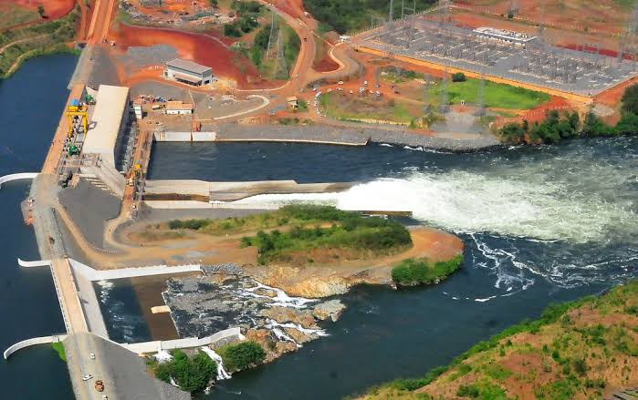

(a) Giving evidence from the photograph, identify the economic activity taking place in the photograph.  **(2marks)**

(b) Describe the factors which have favored the activity identified in (a) above.  **(5marks)**

(c) Explain the problems facing the people carrying out the economic activity. **(6 marks)**

(d) Giving reasons for your answer, suggest two areas in East Africa where the photograph could have been taken.  **(2marks)**

**3. COMPULSORY QUESTION: FIELDWORK (15 MARKS)**

For any **one** fieldwork study you have carried out as a group or an individual:

(a) State the:

(i) Topic of your study **(1 mark)**

(ii) Objectives of your field work study.  **(3 marks)**

(b) Draw a cross section through the area studied and on it mark and name relief and human features.  **(5 marks)**

(c) Describe how you used **any two** of the following methods to collect information in the field;

1. Interviewing
2. Observation
3. Recording  **(4 marks)**

(d) Explain the challenges you faced by using the methods described above.

**(2 marks)**

**SECTION B: EAST AFRICA (20 MARKS)**

Answer only **one** question from this section.

4. (a) (i) What is meant by a water fall?  **(3 marks)**

(ii) Name any **two** rivers in East Africa which have waterfalls. **(2 marks)**

(b) Describe the conditions which have led to the formation of water falls in

East Africa.  **(6 marks)**

(c) Explain the benefits of waterfalls to the people of East Africa*.* **(5 marks)**

(d) Outline the problems faced in the utilization of rivers in East Africa. **(4 marks)**

1. Study the map of East Africa below and answer the questions that follow:

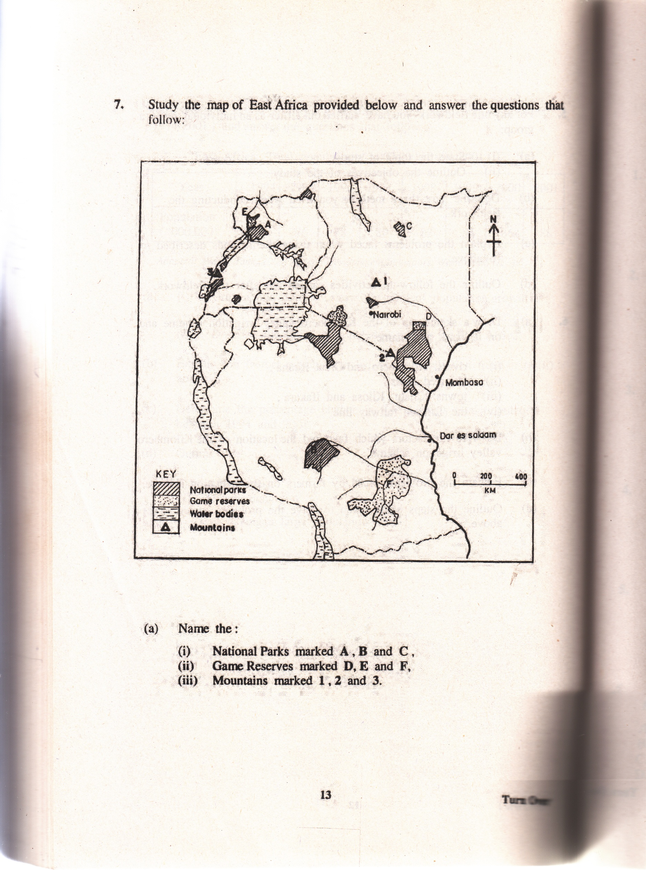

**3**

**B**

F

1. Name the;
2. National parks marked **A, B**  and **C**
3. Game Reserves marked **D, E**  and **F**
4. Mountains marked **1, 2**  and **3** **(09 marks)**
5. Describe the factors which have favoured the tourist industry in East Africa.

**(04 marks)**

1. Explain the problems facing the tourist industry in East Africa.**(04 marks)**
2. Outline the steps which have been taken to promote the tourist industry in East Africa.

**(03 marks)**

1. (a) Draw a sketch map of the Kilombero valley irrigation scheme and on it, mark

and name;

1. Rivers: Kilombero and Great Ruaha
2. Irrigated areas,
3. Towns: Kidatu, Kilosa and Ifakara
4. The Tanzam railway line **(08 marks)**

(b) Describe the factors which favoured the location of the Kilombero valley irrigation scheme. **(04 marks)**

(c) Explain the problems faced by farmes on the irrigations scheme. **(04 marks)**

(d) Outline the steps being taken to solve the problems state in (c) above.

**(04 marks)**

**End**